*\*&---------------------------------------------------------------------\**  
*\*& Modulpool  ZTR_CGKL_MPOOL_TABSTRIP*  
*\*&*  
*\*&---------------------------------------------------------------------\**  
*\*&*  
*\*&*  
*\*&---------------------------------------------------------------------\**  
PROGRAM ZET_MPOOL5.  
“LV_TABSTRIP MUST BE THE NAME OF TABSTRIP  
CONTROLS LV_TABSTRIP TYPE TABSTRIP.

“THESE MUST BE THE NAME OF INPUT AND OUTPUT FIELDS  
DATA : LV_VAR1 TYPE I,  
       LV_VAR2 TYPE I,  
       LV_SUM  TYPE I.  
*\*&---------------------------------------------------------------------\**  
*\*&      Module  STATUS_0100  OUTPUT*  
*\*&---------------------------------------------------------------------\**  
*\*       text*  
*\*----------------------------------------------------------------------\**  
MODULE STATUS_0100 OUTPUT.  
  SET PF-STATUS SPACE.  
*\*  SET TITLEBAR 'xxx'.*  
ENDMODULE.  
*\*&---------------------------------------------------------------------\**  
*\*&      Module  USER_COMMAND_0100  INPUT*  
*\*&---------------------------------------------------------------------\**  
*\*       text*  
*\*----------------------------------------------------------------------\**

*“TAB1 AND TAB2 MUST BE THE VALUR OF TABS IN TABSTRIP*  
MODULE USER_COMMAND_0100 INPUT.  
  CASE SY-UCOMM.  
    WHEN 'TAB1'.  
      LV_TABSTRIP-ACTIVETAB = 'TAB1'. *"FCT CODE*  
    WHEN 'TAB2'.  
      LV_TABSTRIP-ACTIVETAB = 'TAB2'. *"FCT CODE*  
  
    WHEN 'BACK' OR 'CANCEL' OR 'EXIT'.  
      LEAVE TO SCREEN 0.  
  ENDCASE.  
  
ENDMODULE.  
  
  
  
MODULE STATUS_0120 OUTPUT.  
  
  LV_SUM = LV_VAR1 + LV_VAR2.  
  
ENDMODULE.

====================================================================

PROCESS BEFORE OUTPUT.  
 MODULE STATUS_0100.

“CREATE DIFFERENT SUB SCREENS FOR EACH TABS  
CALL SUBSCREEN SUB1 INCLUDING SY-REPID '0110'.  
CALL SUBSCREEN SUB2 INCLUDING SY-REPID '0120'.  
  
PROCESS AFTER INPUT.  
 MODULE USER_COMMAND_0100.  
  
 CALL SUBSCREEN: SUB1, SUB2.

PROCESS BEFORE OUTPUT.  
*\* MODULE STATUS_0110.*  
*\**  
PROCESS AFTER INPUT.  
*\* MODULE USER_COMMAND_0110.*

PROCESS BEFORE OUTPUT.  
 MODULE STATUS_0120.  
*\**  
PROCESS AFTER INPUT.  
*\* MODULE USER_COMMAND_0120.*

Screen 100

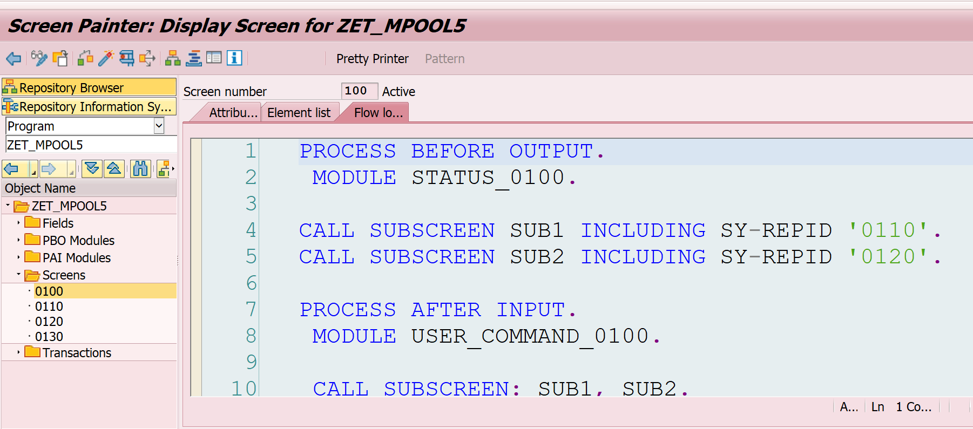

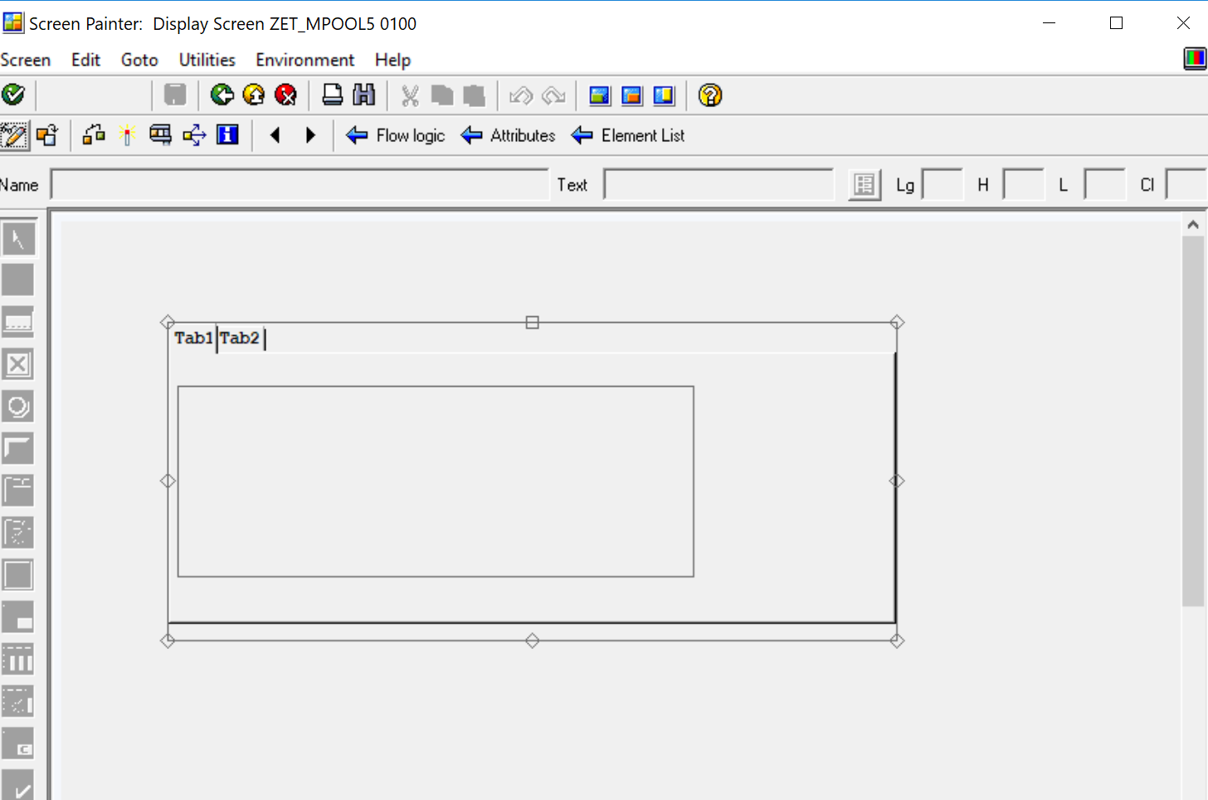

Sreen 110

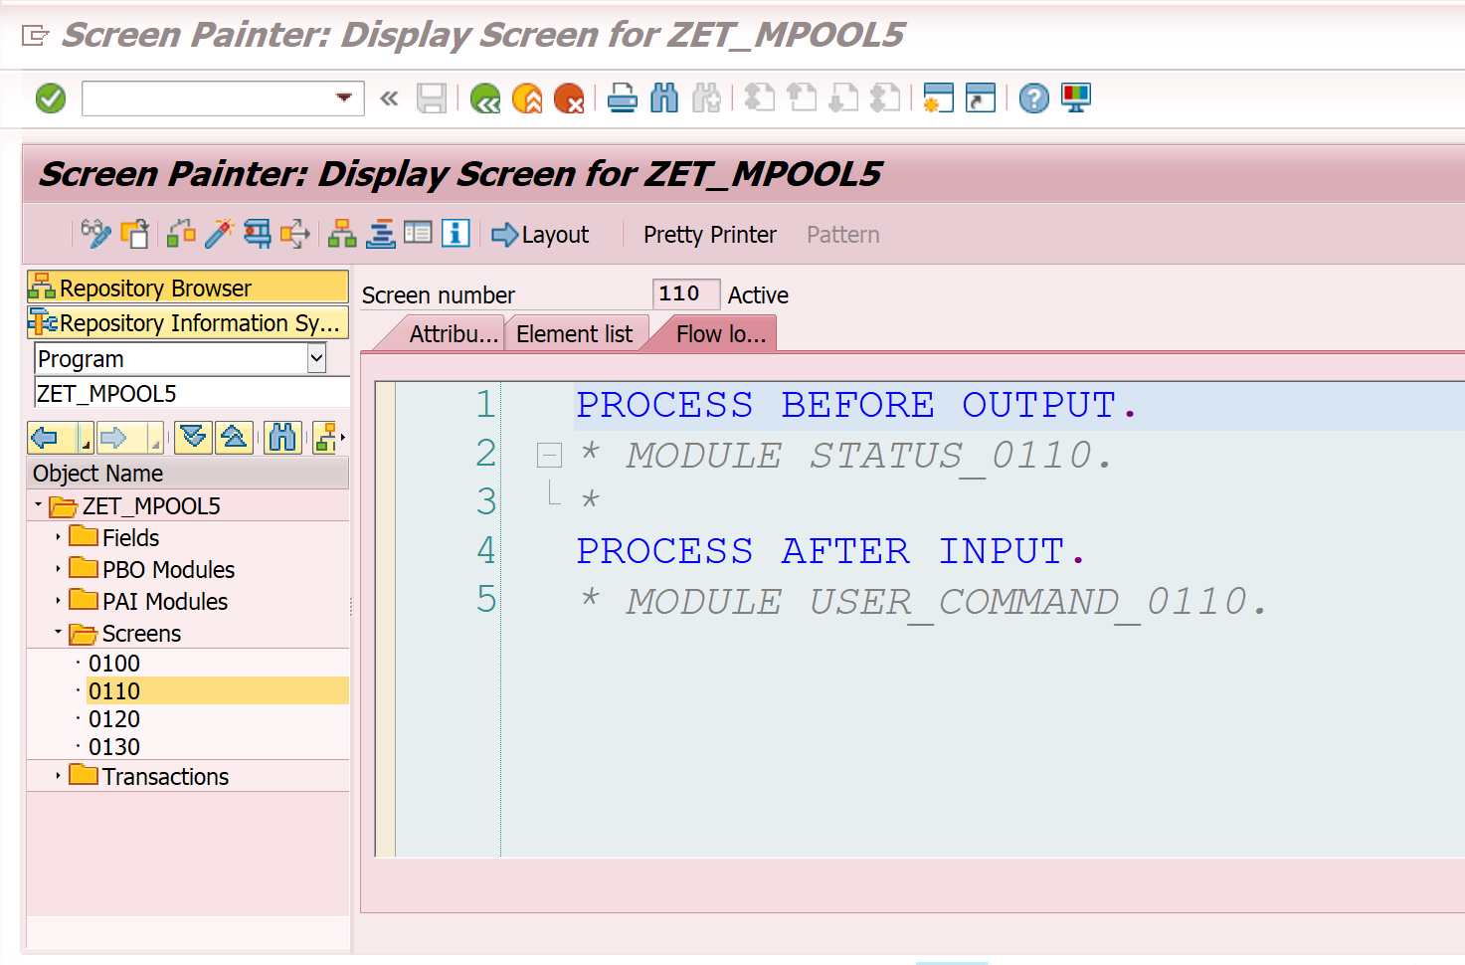

INPUT TYPE MUST BE INT4

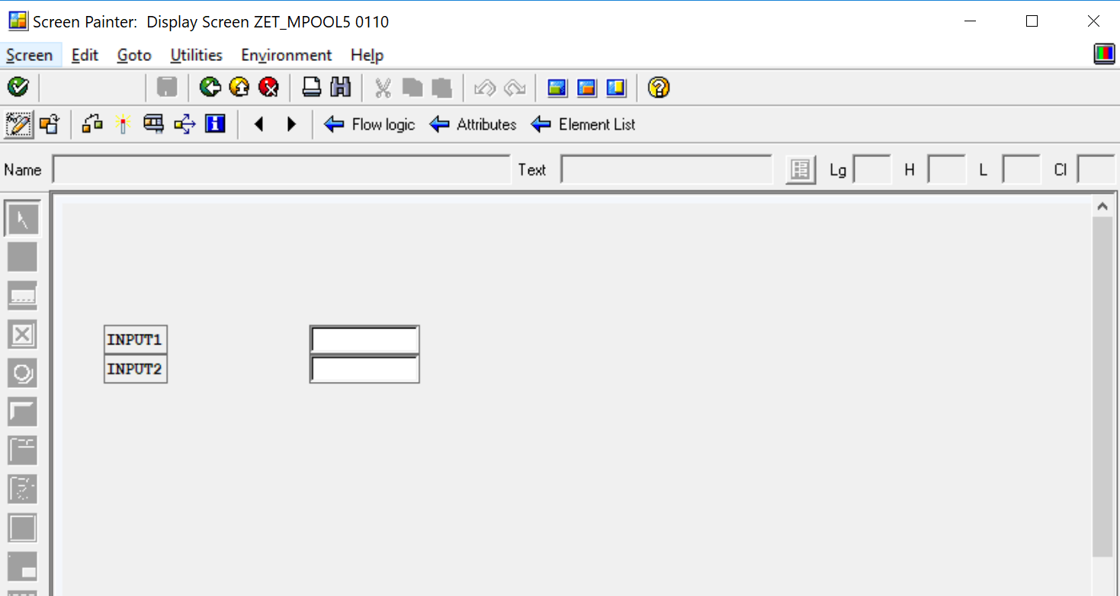

Screen 120

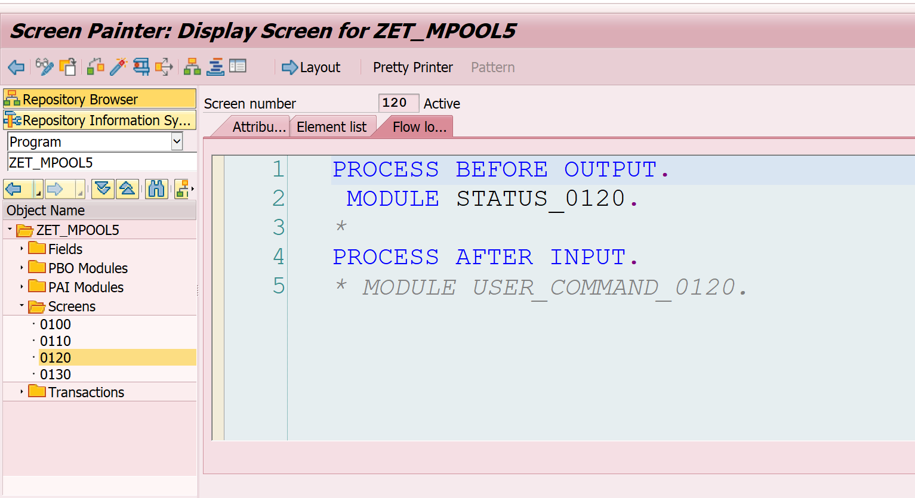

OUTPUT DATA TYPE MUST BE INT4 AND SHOULD UNMARK INPUT FIELD IN ATTRIBUTES

